HW1: Mid-term assignment report
Ana Alexandra Antunes [876543], v2025-10-22

1 Introduction 1
1.1 Overview of the work 1
1.2 Current implementation (faults & extras) 1
2 Product specification 2
2.1 Functional scope and supported interactions 2
2.2 System implementation architecture 2
2.3 API for developers 2
3 Quality assurance 3
3.1 Overall strategy for testing 3
3.2 Unit and integration testing 3
3.3 Acceptance testing 3
3.4 Non-functional testing 3
3.5 Code quality analysis 3
3.6 Continuous integration pipeline [optional] 4
4 References & resources 4

<All remarks in this color should be removed from the final document!
This a template for the expected content/structure. You may use any editing tool to prepare the report (LaTeX included).
Feel free to write in Portuguese or English, but do not mix languages between headings and body…>

Introduction

Overview of the work
This report presents the midterm individual project required for TQS, covering both the software product features and the adopted quality assurance strategy.
<briefly introduce your application use case: name the product, if applicable; what is its general purpose, in your words?>

Current implementation (faults & extras)
<explain the known limitations features that are missing or faulty but were expected! >

< if applicable: clarify which extra features did you implement. Are there relevant additions you decided to include?>

Use of generative AI
Clarify how did you use AI-assistants for production and test code.
Be clear about the parts you prefer not to delegate.

Product specification

Functional scope and supported interactions
<who (actors) will use the application and for what? Explain the main interactions; include/explain the experience with a visual summary. >
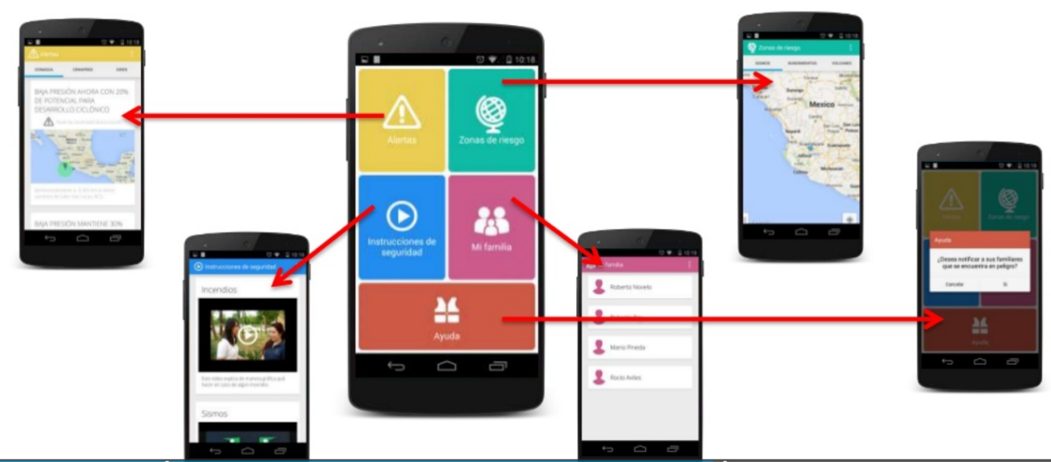

System implementation architecture
<briefly present the software architecture.>
<detail the specific technologies/frameworks that were used>

API for developers
<what services/resources can a developer obtain from your project? document your API endpoints>

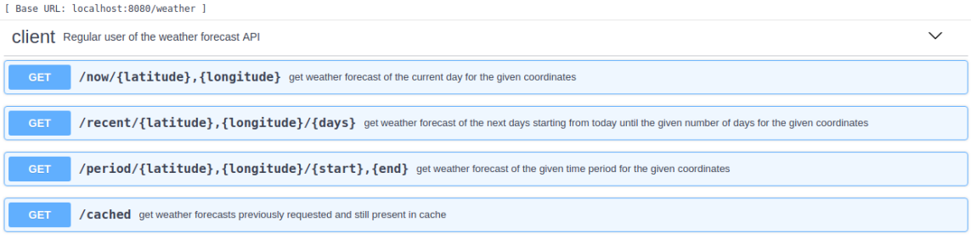

Quality assurance

Overall strategy for testing
[what was the overall test development strategy? E.g.: did you do TDD? Did you choose to use Cucumber and BDD? Did you mix different testing tools, like REST-Assured and Cucumber?...]

Unit and integration testing
[where did you use unit and integration test? for what? which was the implementation strategy?]
[may add some screenshots/code snippets for clarification, but do not dump all tests here….]

Acceptance testing
[which user-facing test cases did you considered? How were they implemented and automatized?]
[may add some screenshots/code snippets for clarification]

Non-functional testing
[which non-functional test cases did you consider? Expected: performance study with, at least, load tests]

Code quality analysis
[which tools/workflow did you use to for static code analysis?
Show and interpret the results.]
[you may add some interesting lessons learned, e.g., some code smell reported by the tool that was difficult to spot and otherwise you wouldn’t address it]

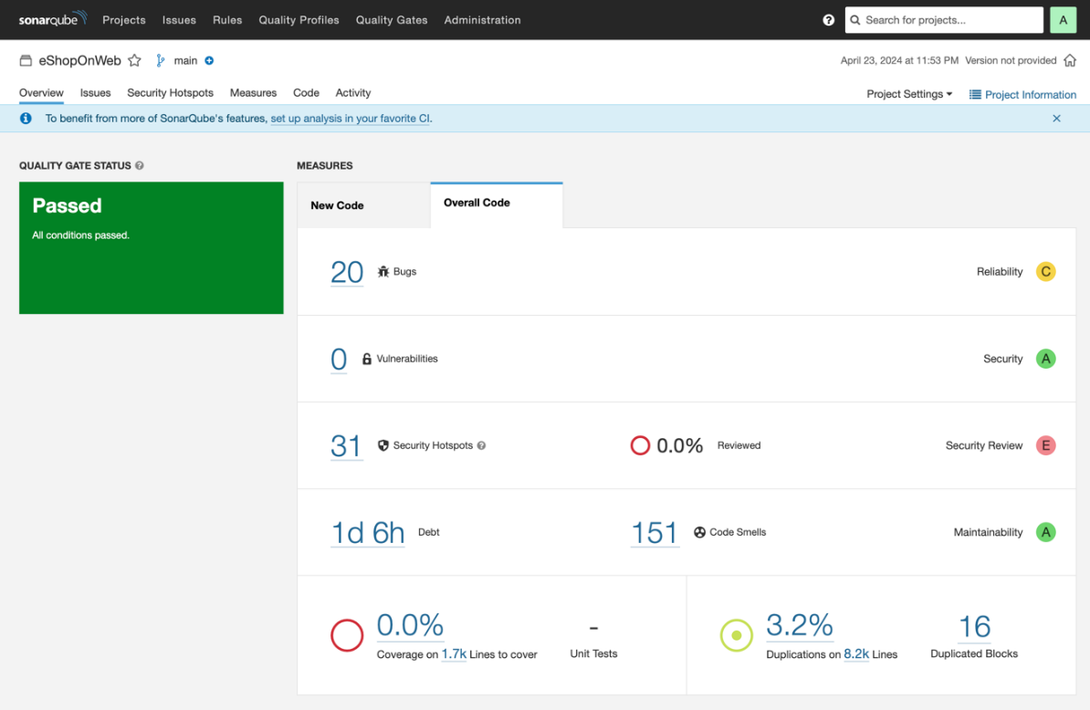

Continuous integration pipeline [optional]
[did you implement a CI pipeline? What was the setup? Illustrate with screenshots, if applicable]

References & resources
Project resources
Resource: | URL/location:
Video demo | <short video-demonstration of your solution; copy into the Git folder, under /docs>
QA dashboard (online) | [optional; if you have a quality dashboard available online (e.g.: sonarcloud), place the URL here]
CI/CD pipeline | [optional; if you have th CI pipeline definition in a server, place the URL here]

Reference materials
<If applicable: document the key components (e.g.: libraries, API) or key references (e.g.: blog post) that were helpful and certainly would help other students pursuing a similar work>

